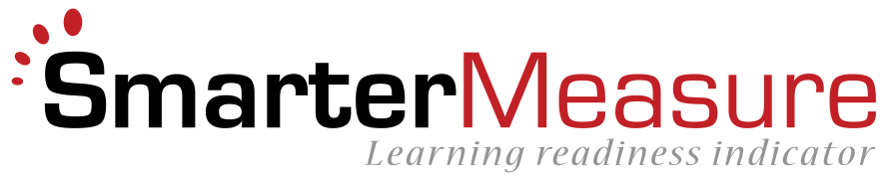
Good practices in integrating the SmarterMeasure Learning Readiness Indicator into an orientation course

Many institutions integrate SmarterMeasure into some sort of orientation course. At some institutions this is an on-campus freshman orientation course for traditional-aged students. At other institutions it is a fully online orientation course for online learners. At some institutions the orientation is required, at others it is optional. Recognizing that considerable variance exists in the way that schools provide their orientation, this document is provided to share some good practices that schools have used to foster reflection and prompt action from students based on their SmarterMeasure scores.
- DISCUSSION BOARD – Some faculty members have crafted a discussion board question through which students can reflect on their SmarterMeasure scores within the community of the course. Well written questions do not just prompt students to report their scores, but to reflect upon their scores by sharing what they considered meaningful in their scores, steps they could take to grow in their opportunities for improvement, resources for support that they found useful, etc. Students often comment that the replies to their postings from other learners have been comforting in helping them to realize that they are not alone as a distance learner.
- REFLECTION PAPER – Some courses have an assignment in which students compose a brief (two or three pages) paper in which they reflect on their SmarterMeasure scores. The purpose of this paper is two-fold: (1) It prompts the student to actually read in detail their SmarterMeasure score report and to reflect upon the findings, and (2) It provides an early sample of the student’s writing abilities. The SmarterMeasure score report contains quite a bit of information. If the score report was printed, it would exceed 18 pages of information. Many students simply look at the graphical representation of their scores and do not drill down into the tabbed pages with the interpretation of their scores. A writing assignment prompts the students to look at all of their scores and information.
- PERSONAL DEVELOPMENT PLAN – As an assignment in the orientation course, some schools require students to develop a personal/professional development plan. Through this plan the student articulates how they would like to improve themselves through education. One component of the plan is an analysis of their strengths and opportunities for improvement as identified by SmarterMeasure. An advantage of this strategy is that the student not only identifies their opportunities for growth, but connects these to actionable strategies for improvement.
- GROUP ACTIVITY – “Birds of a feather learn together.” This is an adaptation of a common statement, but it remains true that students may experience a greater degree of comfort and success in an activity when participating with others who are “like them.” Some schools have used SmarterMeasure scores to place students into groups based on categories measured by the assessment. For example, students may be placed into groups based on their dominant learning style. Then working as a group, the students identify and explore what it means to be a learner with that learning style in an online course.
- RESOURCE RECOMMENDATION – Some orientation courses have assigned students to utilize one or more of the free resources for support links on the SmarterMeasure score report. Then after using the resource, students are tasked to report on the resource indicating the degree to which they found it helpful. When this is done through a discussion board, students will benefit from reading about what other students found useful. Students may also be asked to submit other resources of which they are aware that they consider useful. Schools then have the ability to customize their resources based on this student feedback.

